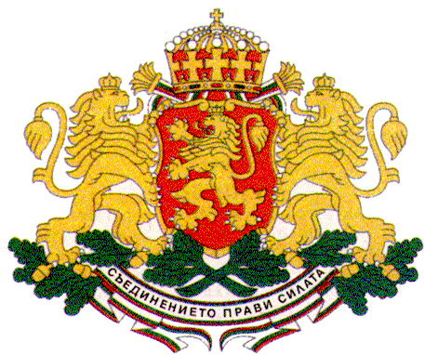 | PERMANENT MISSION OF THE REPUBLIC OF  BULGARIA  TO THE UNITED NATIONS

11 East 84th Street, New York, NY 10028, Tel: (212) 737 4790, Fax: (212) 472 9865, e-mail: bulgaria@un.int

High-level Event of the UN General Assembly
Marking the 20th Anniversary of the World Programme of Action for Youth to Highlight Youth Priorities in the Post-2015 Development Agenda

Plenary
Statements by Member States

H.E. Mr. Stephan Tafrov, Ambassador, Permanent Representative of Bulgaria to the United Nations

New York, 29 May 2015 (GA Hall)

Mr. President,
Twenty years ago the UN adopted the World Programme of Action for Youth which provided a comprehensive policy framework and practical guidelines for improving the situation of youth both nationally and globally. Since then significant progress has been made in promoting youth development and participation but still a lot remains to be done for the full realization of the fifteen priority areas as identified in the World Programme.
Bulgaria acknowledges the continued relevance of the WPAY and is taking special measures to enhance its implementation both domestically and internationally.
Mr. President,
The Bulgarian Government has developed a National Strategy for Youth which is being implemented by the different institutions through the elaboration of relevant Programmes of Action. The Strategy includes measures aimed at integrating a youth perspective in Government policies and ensuring the full enjoyment of human rights for young people. The Strategy functions as an important tool for mobilizing and pooling the efforts of central institutions, local authorities, social partners and NGOs for creating a supportive environment for young people, so that they could meaningfully participate in public life and reach their full potential.
In 2013 a High-level National Council for Youth has been established under the Minister of Youth and Sports as a consultative body that ensures better policy making with regard to youth affairs. The Council serves also as a useful platform for communication and coordination between the different Government institutions and youth organizations.
At local level the youth agenda is implemented by the Regional Governors who analyze the specific needs of youth in the respective region and take the necessary measures for their fulfillment with the help of the central government, the civil society and youth organizations on the field.
Mr. President,
The Government of Bulgaria attaches great importance to the rights of young people and their meaningful involvement in all spheres of the political and public life. Youth participation in decision-making processes is a key objective on the youth agenda both at national level and globally. Bulgaria promotes actively the participation of young people at international fora through the UN youth delegate programme. Since 2007 youth delegates have been included regularly in Bulgaria’s official delegations to the Third Committee of the UN General Assembly and to the Commission for Social Development of the UN Economic and Social Council, and their voice has been heard and taken into consideration.
Mr. President,
Bulgaria undertakes sustained and coordinated measures for creating opportunities and improving the well-being of young people, especially of those belonging to the most vulnerable and marginalized groups, including children and youth with disabilities.
With the post-2015 negotiations entering their final and crucial stage Bulgaria continues to advocate actively for integrating youth in the new development agenda and ensuring the meaningful participation of young people in all processes that affect their lives.

Thank you, Mr. President.

